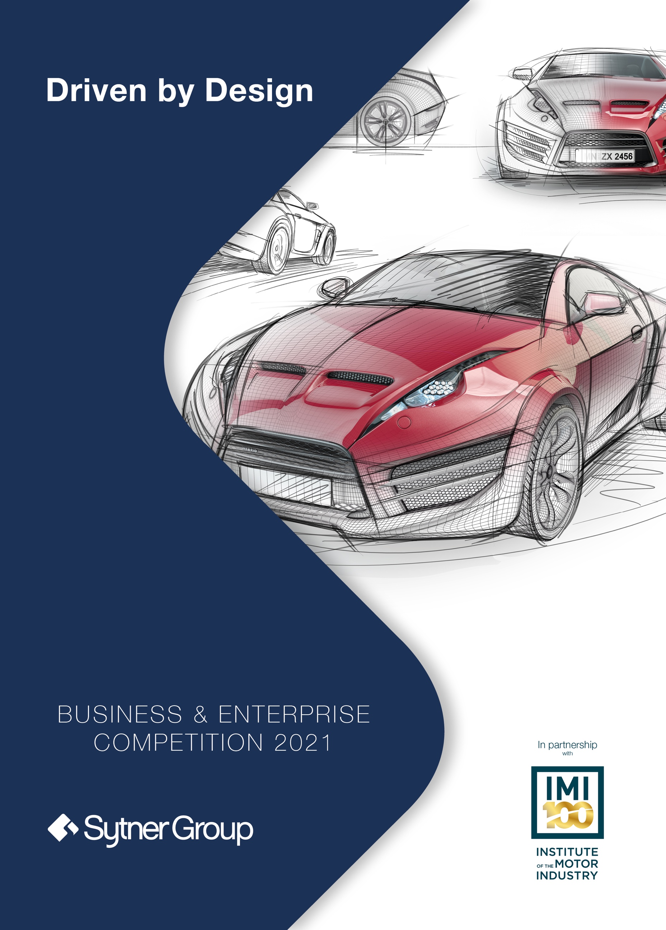

Sytner Group - In partnership with IMI (Institute of Motor Industry)

Competition Brief
Allow approximately half a day - 1 day to complete the tasks detailed below.

For this year’s competition we want you to recognise that many parts of the world have changed in the last
12 months, therefore we want you to think about something which might have affected you, or someone close
to you recently.

That could be from one of the scenarios listed below or you can describe an issue of your choice relating to one of the following topics, such as Mental Health and Well-being, Social Distancing, Coronavirus, The environment, Diversity and Inclusion and Brexit. The Concept Car should include an element which would help overcome, address or raise awareness.

- Scenario 1: Design a new public transport of the future – how can you entice more people
to use public transport more and reduce their need for a personal vehicle?

- Scenario 2: How will you support a single person living in a city with limited parking and limited
income to be able to afford a vehicle within a restricted emissions zone

- Scenario 3: A Family of 5 who are concerned about sustainability, impact on the environment
and safety for their family.

- Scenario 4: An older couple who live in a retirement home, they have pets and are concerned
about their future health needs.

- Scenario 5: A new type of Heavy Vehicle that can transporting goods long distances and that
is environmentally friendly as well as safe and a comfortable environment for the driver.

This is completely open to your interpretation, we want to see your imagination in your designs.

You are responsible for designing, marketing and launching your car of the future, so let’s get creative!

Below you will find everything you need to complete the competition – make sure you note down all of your research and ideas so we can see how you have developed your design!

Where possible, please complete this document electronically and send the completed version
to schoolcompetition2021@sytner.co.uk by no later than February 28th 2021 for your chance to win.

You can also print and complete the worksheet by hand. You will need to either scan your worksheet
or take pictures of each sheet and email them back to us.

Please take photographs of any designs and drawings and attach these to your email explaining
clearly which section of the worksheet they relate to.

Background Information:

The Business & Enterprise competition will focus and improve students’ skills such as
teamwork, communication, leadership, employability and life skills. Roles you will be
undertaking will include Project Management, Sales and Marketing, Research and Design.

About Sytner Group

Sytner Group are the UKs leading retailer of prestigious cars and the largest overall automotive
retailer in Europe. Sytner Group represent 21 of the world's most prestigious car manufacturers in over
140 dealerships across the UK. As well as being the UKs largest dealership group we are the number
one retailer for many of our manufacturers.

About the Institute of the Motor Industry (IMI)

The IMI is the professional body for individuals working in the motor industry and the authoritative voice
of the retail automotive sector. The IMI’s aim is to ensure that the automotive retail sector has a skilled, competent and professional workforce that is fully equipped to keep pace with the demands
of new technology and changing markets.

Parents’ Guide

Parents we know this is a very difficult time juggling working and home schooling so we have pulled
together a lesson plan that forms part of the National Curriculum for Business and Enterprise.

Below you will find a Competition pack which contains 4 lesson plans, to support your child with their communication, problem solving, planning and research skills whilst trying out various job roles in the
automotive industry including marketing, design and sales.

It is your choice whether to use the activities as a whole day of learning or as 4 separate sessions,
as long as these are submitted to schoolcompetition2021@sytner.co.uk by the 28th February 2021.

Lesson 1: Planning and Research.

Task 1: Planning
Choose a target audience and an issue to fix from the ones listed in the competition brief. If you have another problem you would like to help people overcome then explain their needs and requirements below.

Planning

You will need to research their preferences, lifestyles, hobbies and finances etc.

My target market is:

I chose this audience because:

Task 2: Research
Research the types of vehicles already available to your chosen target audience and consider what this will look like in the future. What are the good bits and what could be improved? What technology will be available in the next 10 years? Why would all of these things appeal to that audience?

Then answer these questions below:

What are the main concerns and issues that your target audience need to overcome?

What is available to your target audience now?

What do you think they will need in the future?

Lesson 2: Problem Solving and Design

Task 3: Problem Solving
Key Features & Your Unique Selling Point (USP)

Look back at tasks 1 and 2, remind yourself of the person or people you are designing your vehicle
of the future for. What were their needs? What was currently already available to them and what would
they need in the future?

Now that you know your target audience and their requirements you need to come up with some key features and a ‘unique selling point’ that will make them choose to buy your vehicle and not one from a competitor.

It's time to get creative!
Design and draw your USP:

Explain your Unique Selling Point – either draw or tell us about your USP

Tell us WHY this will support and help your target audience?

Task 4: Design

You now know your target audience and their needs, what is available for them at the
moment and also what your unique selling point for them is. Now it’s time to design your
overall vehicle. What will it look like? What will its shape be? What colour combinations
and materials will you offer and why?

Show us your final image of your new vehicle, remember to highlight the key features and USP!

Lesson 3: Marketing.

Task 5: Marketing

Name, logo and strap line

Now you know who your audience is, what their needs are and how your vehicle will fit them it’s time to name your vehicle. What will appeal to your audience and what will showcase your USP?

Name

Write down some ideas for your vehicles name

Decide on the final name your vehicle and tell us why you chose this

Design your vehicle logo

Now you have the name of your vehicle it needs a logo to make it stand out!
Take a look at other logos around the house to see what stands out and what colours
and shapes work well together.

Take some time to design your new logo and tell us why you chose and why it will appeal to your target audience

Strap line

To go along with your name and logo you will need to think of a marketing strapline
for promoting your vehicle keeping in mind your target audience.

To start you off can you guess where these ones are from?

- ‘Because you’re worth it’
- ‘Just do it’
- ‘Taste the Rainbow’
Now it’s time to come up with a marketing strapline for your new car.

Your ideas

Your final strapline and why

Lesson 4: Communication and Sales.

Task 6: Communication

Advertising your vehicle

You will want to promote your new vehicle to the general public and an advertising poster is a great
way of doing this.

Research how and where will you advertise your new vehicle? Remember your target market and what would appeal to them. Find some examples of advertising around the house, what works well and what would work
for your audience?

Advertising campaign - Poster

Design an advertising poster and advertising campaign for your vehicle, let us know where it will be displayed

Advertising campaign - Social media posts

Devise a promotional plan by creating a media campaign to launch the vehicle onto the market:
Which media platforms would you use to sell your product? Will there be a limited edition
or special offer for the launch? What social media posts will there be around the launch
of your new vehicle?

Advertising campaign - Launch event

Describe your launch event – when, where, what, who?
Tell us how you plan to launch the new vehicle onto the market. How will you launch your product?
Where will your launch event be? What will happen at your launch event? Who is your brand ambassador?

Competition Submission Form
Congratulations, you have designed your new Concept car
and prepared for its launch. Let’s check that you are you ready
to submit your entry?

If you have completed this worksheet on a computer/tablet please save and send your final version to schoolcompetition2021@sytner.co.uk. If you have any drawings or designs on paper you can take pictures or scan and attached them to your email.

If you have printed the worksheet and completed by hand, you can either Scan your worksheet or take pictures of each sheet and email them back to us at schoolcompetition2021@sytner.co.uk

Parent / Guardian Details:

Title:
First Name:
Surname:

Address:
Town:
County:
Postcode:

Contact Number: Email Address:

Student Details:

Year Group:

School Details:

School:

Where did you hear about this competition?

All entries must be received no later than February 28th 2021 for your chance to win.

Good Luck! We look forward to receiving your design!

Under 16? We can only accept entries to this competition directly from your parents or legal guardian if you are under 16 years of age with their consent. Please ask your parents or your legal guardian to complete this entry form for you to enter the competition.

Parent/Legal Guardian: I can confirm, I have read and agree to the general terms and conditions and privacy notice. I consent to the processing of my child’s and my personal information for this purpose by the Sytner Group.

